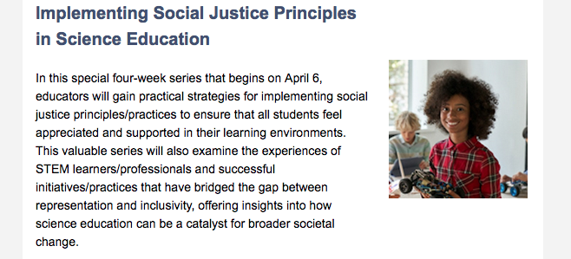

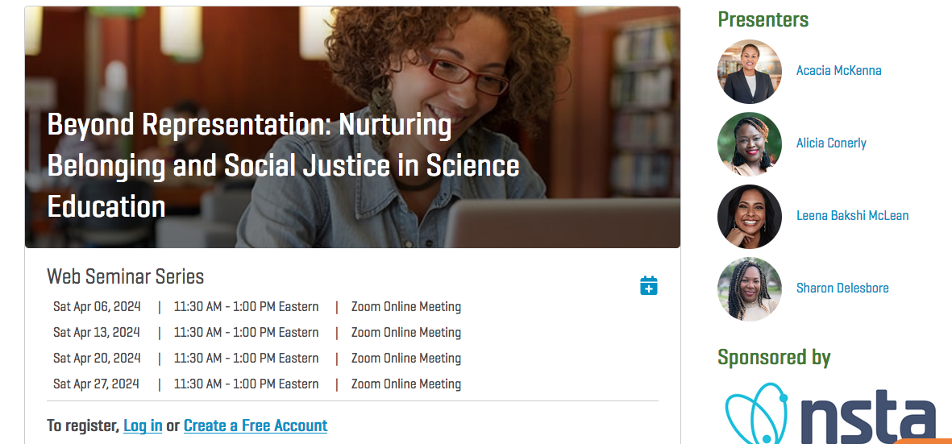



Our own Dr. Leena Bakshi McLean is one of the presenters for an upcoming **NSTA Webinar Series: Beyond Representation: Nurturing Belonging and Social Justice in Science Education:**

<https://my.nsta.org/event/beyond-representation-nurturing-belonging-and-social-justice-in-science-educatio>  on four Saturday mornings in April!



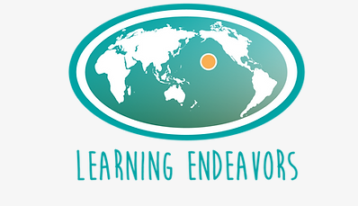

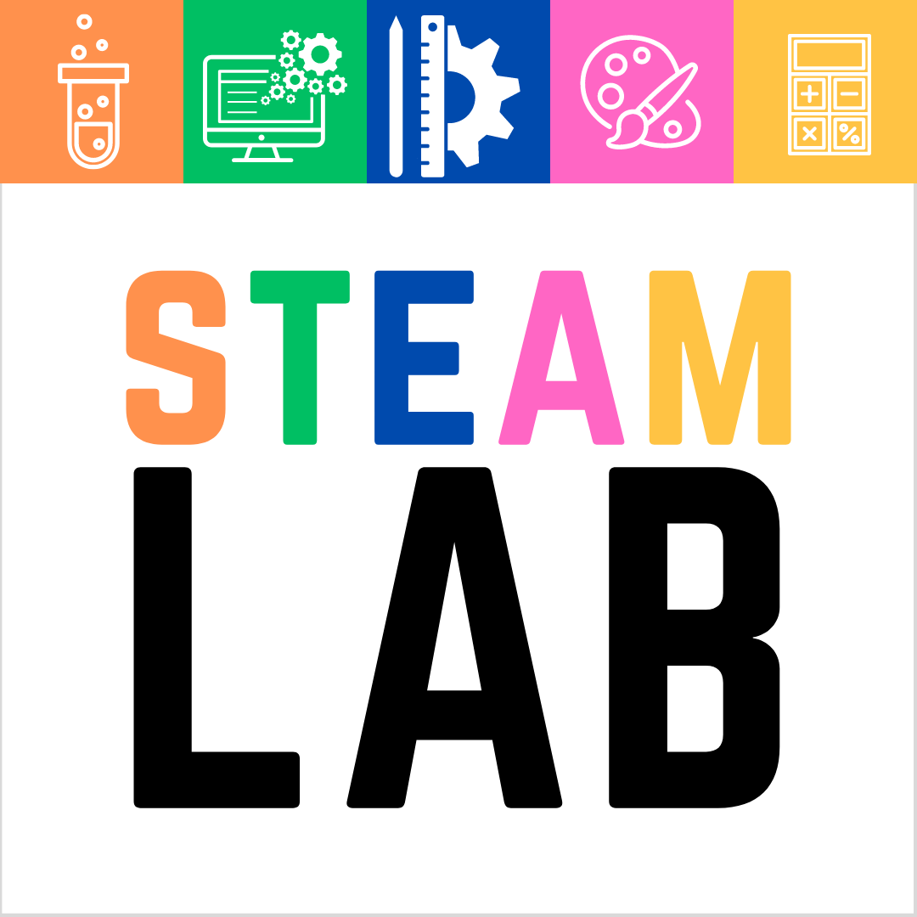

Check out the opportunities at Learning Endeavors!

<https://www.learningendeavors.org/classesforyouth>

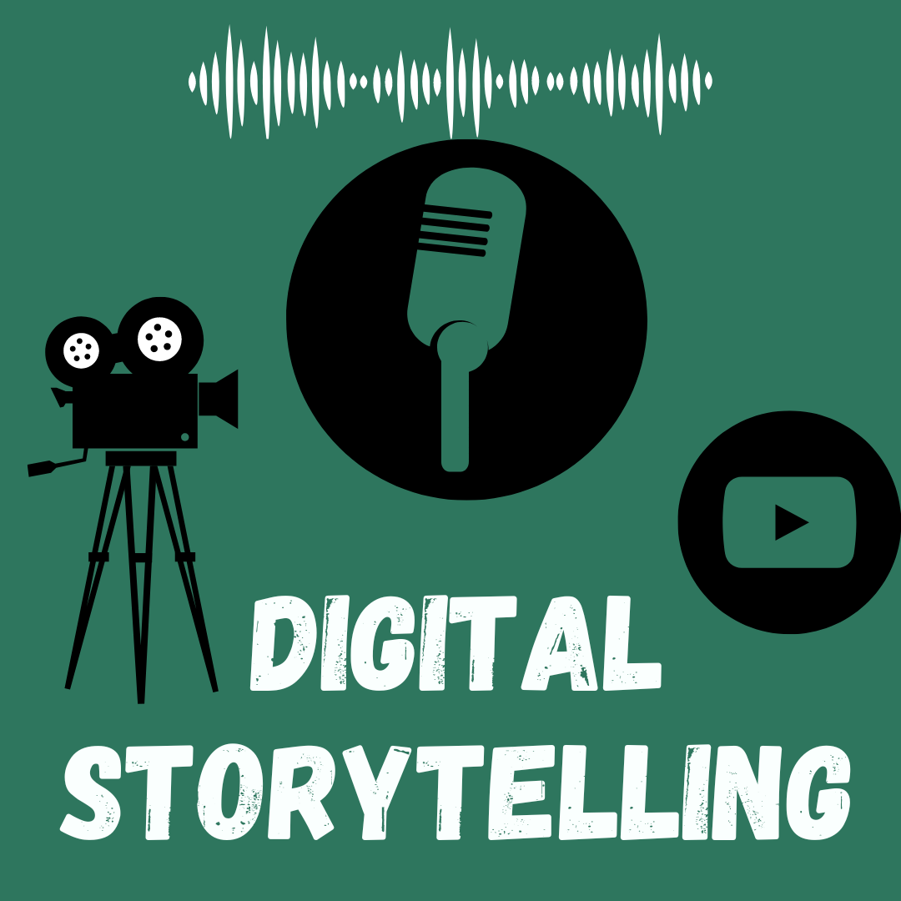 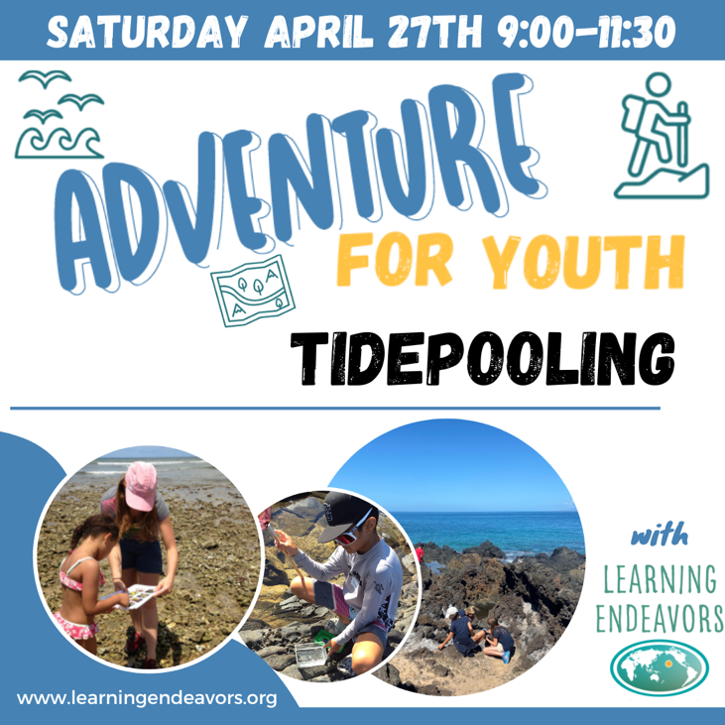

[](https://gizmos.explorelearning.com/)

See pdf attached to newsletter for all active links.

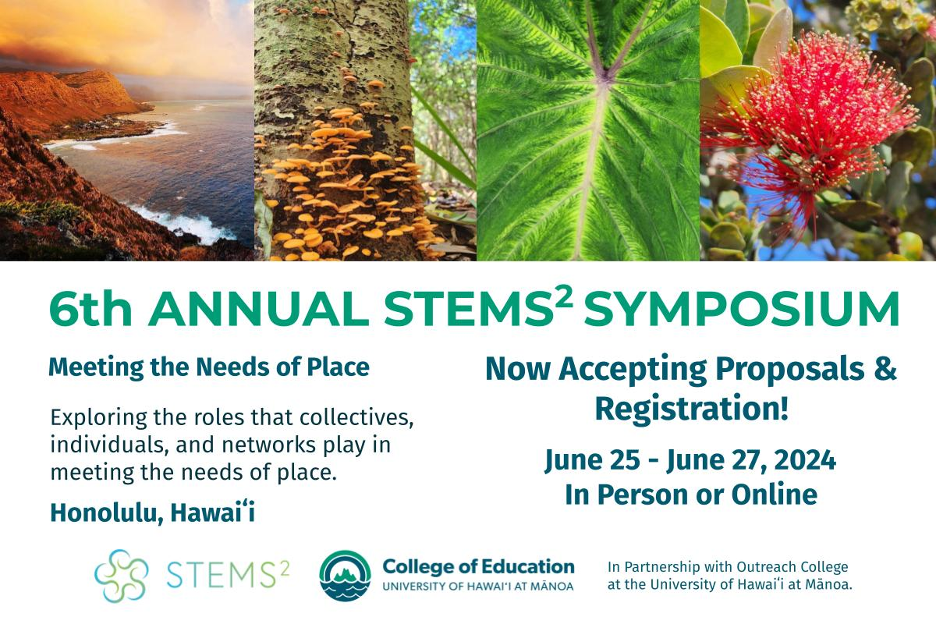

**Join Us -**[**Register Here**](https://docs.google.com/forms/d/e/1FAIpQLSdo7SvJCggn-Xqr4FQ9-in37rwJB4rUtp98S_D0pRKokgDR4g/viewform)

The 6th Annual STEMS² Symposium will take place Tuesday, June 25 – Thursday, June 27, 2024 with opportunities to **engage both in person and online**. In-person experiences will include activities that physically engage participants with people and places around O‘ahu. Online experiences will include workshops, poster sessions, and talk stories/paper presentations. Whether you participate locally on Oʻahu or from a distance, join fellow[STEMS²](https://coe.hawaii.edu/stems2/about/) enthusiasts who share a passion for exploring the roles that place, culture, and identity play in interdisciplinary education.

**Proposals Due March 31st -**[**Please Submit a Proposal**](https://coe.hawaii.edu/stems2/symposium/2024/?submissions)

Now accepting proposals for online and in-person talk story sessions, paper sessions, performances, and workshops as well as in-person service learning experiences, and workshops. Grounded in the value of Aʻo (to teach and learn in a reciprocal relationship), we work to create inclusive, interactive spaces to hear as many voices as possible in multiple session formats. Please submit a proposal that you believe relates to this year’s symposium theme. To support your proposal design, below is a list of suggested topic areas:

* Planning and implementing STEMS² Units and/or other place and culture-based interdisciplinary or transdisciplinary planning approaches
* Building relationships between schools and communities that foster authentic and reciprocal partnerships
* Sessions or event proposals that intentionally build relationships or connections among educators and practitioners
* Research approaches and projects exploring the impacts and possibilities for place and culture-based interdisciplinary and transdisciplinary practices.
* Stories of challenge and failing forward when aiming to transform your personal practice, systemic structures, and dominant narratives.

To access the proposal form and read more about the session types and symposium theme visit the [2024 STEMS² Symposium website](https://coe.hawaii.edu/stems2/symposium/2024/).

Hope we get to learn with and from you this summer! STEMS2