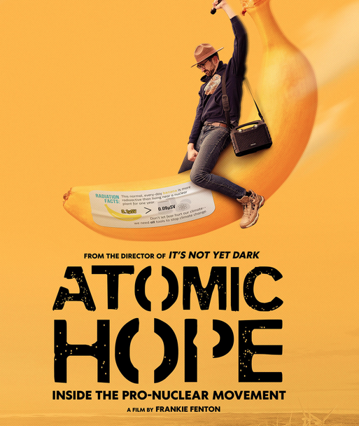

I am reaching out today because Generation Atomic, Picture Motion and filmmakers Frankie Fenton & Kathryn Kennedy would love to invite you and your community members, students, educators, activists and/or anyone else in your network to an exclusive virtual event inspired by Fenton and Kennedy’s documentary Atomic Hope. Don't miss this vital virtual panel that will bring together advocates, and experts, to explore the role of nuclear in clean energy and climate resilience.

Join us virtually on Wednesday, April 3 at 2:30 pm ET / 11:30 am PT. We’ll be showing clips from the film Atomic Hope, followed by special guest remarks and a panel discussion. Attendees will have access to an exclusive virtual on-demand screening of the full film too — so they can watch the film before this live panel event.

To reserve a spot, RSVP for the virtual event using the link below or share with anyone else to register:

STORYTELLING, NUCLEAR ENERGY AND CLIMATE CHANGE
WEDNESDAY, APRIL 3
2:30 PM ET/1:30 PM CT/11:30 AM PT
RSVP HERE

Reach out with any questions by replying to this email. Additional information and details will be sent to confirmed guests closer to the event.
In addition to attending, we’d love your help spreading the word on social media and in any newsletters or email blasts. See below for social media and email copy. Thank you so much for any support you can provide!

NOAA Volunteer Opportunities

Please see our upcoming volunteer opportunities. April will be one the busiest months yet!

I would greatly appreciate you passing this information along to your organization.

We have moved to signup.com for all of our events. It makes everything more streamlined and organized.

https://signup.com/go/AksbXjs (ITIC wave tank cleaning 4/4)

https://signup.com/go/VtRZGPr (Onizuka Day - community outreach event 4/6- UH West Oahu)

https://signup.com/go/VtPVJWu (NOAA IRC school tour 4/9)

https://signup.com/go/dBzMQdB (NOAA IRC school tour 4/11)

https://signup.com/go/uCMSRFu (Bishop Museum Science & Sustainability Fest - community outreach event 4/20)

https://signup.com/go/HKuVvdF (U of H Manoa Community Earth Day - community outreach event 4/22)

https://signup.com/go/QcpBbMx (NOAA IRC school tour 4/23)

https://signup.com/go/QcjShyF (NOAA IRC school tour 4/30)

There are at least two more possible events for the month of April. I will update you when we have confirmation.

Please let me know if anyone is interested in cleaning, organizing, trying out some new crafts/activities, or creating visual content for NOAA IRC.

Mahalo!

Natalie Natusch (she/her/hers)
Education & Outreach Associate/Volunteer Coordinator, Inouye Regional Center, National Marine Sanctuary Foundation
NOAA Inouye Regional Center
1845 Wasp Blvd., Bldg 176
Honolulu, HI 96818
(808) 725-6237

