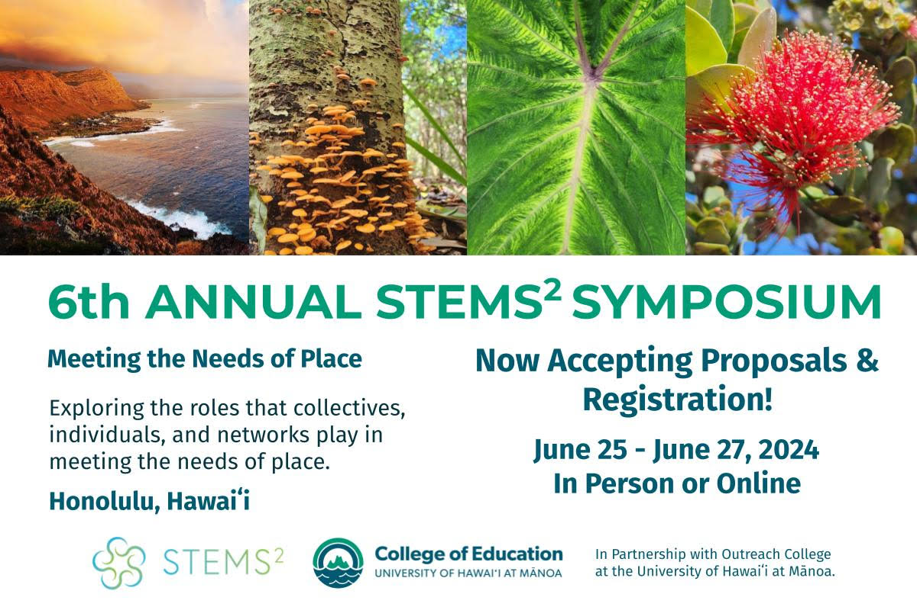

**Join Us -**[**Register Here**](https://docs.google.com/forms/d/e/1FAIpQLSdo7SvJCggn-Xqr4FQ9-in37rwJB4rUtp98S_D0pRKokgDR4g/viewform)

The 6th Annual STEMS² Symposium will take place Tuesday, June 25 – Thursday, June 27, 2024 with opportunities to **engage both in person and online**. In-person experiences will include activities that physically engage participants with people and places around O‘ahu. Online experiences will include workshops, poster sessions, and talk stories/paper presentations. Whether you participate locally on Oʻahu or from a distance, join fellow[STEMS²](https://coe.hawaii.edu/stems2/about/) enthusiasts who share a passion for exploring the roles that place, culture, and identity play in interdisciplinary education.

**Proposals Due March 31st -**[**Please Submit a Proposal**](https://coe.hawaii.edu/stems2/symposium/2024/?submissions)

Now accepting proposals for online and in-person talk story sessions, paper sessions, performances, and workshops as well as in-person service learning experiences, and workshops. Grounded in the value of Aʻo (to teach and learn in a reciprocal relationship), we work to create inclusive, interactive spaces to hear as many voices as possible in multiple session formats. Please submit a proposal that you believe relates to this year’s symposium theme. To support your proposal design, below is a list of suggested topic areas:

* Planning and implementing STEMS² Units and/or other place and culture-based interdisciplinary or transdisciplinary planning approaches
* Building relationships between schools and communities that foster authentic and reciprocal partnerships
* Sessions or event proposals that intentionally build relationships or connections among educators and practitioners
* Research approaches and projects exploring the impacts and possibilities for place and culture-based interdisciplinary and transdisciplinary practices.
* Stories of challenge and failing forward when aiming to transform your personal practice, systemic structures, and dominant narratives.

To access the proposal form and read more about the session types and symposium theme visit the [2024 STEMS² Symposium website](https://coe.hawaii.edu/stems2/symposium/2024/).

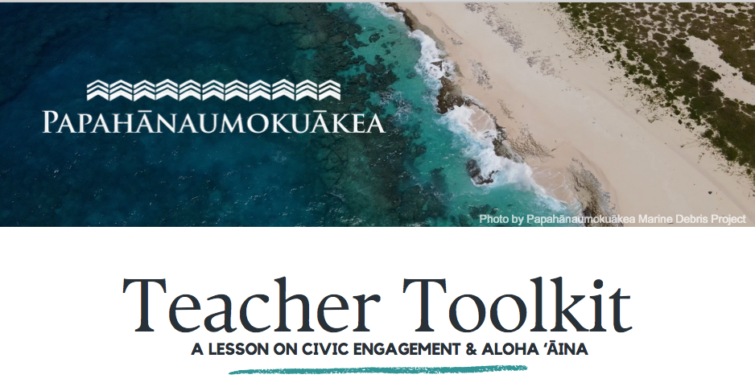

*The Council for Native Hawaiian Advancement has developed a Teacher Toolkit for student/youth engagement with the national marine sanctuary designation process for Papahānaumokuākea over the next two months. (This is not a NOAA product.)*

*The national marine sanctuary proposal documents are scheduled to be released at the beginning of March with a two-month comment period and public meetings across the islands in April. This Toolkit is designed to get youth involved in the process of national marine sanctuary designation and does not advocate for any particular position. The opportunity is rich for youth to come to the public meetings in April and provide comments on the future of Papahānaumokuākea and the proposal to designate the marine waters as a national marine sanctuary*.

*For more information on National Marine Sanctuary designation for marine waters of Papahānaumokuākea visit:*

[*https://sanctuaries.noaa.gov/papahanaumokuakea/*](https://sanctuaries.noaa.gov/papahanaumokuakea/)

The Teacher Toolkit is posted on the [HaSTA website](https://sciencehawaii.com/).

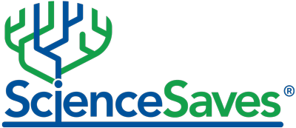

Want to have some fun? Science Clash 2024 is our ScienceSaves tournament, a dynamic campaign designed to highlight historic scientific breakthroughs and their profound impact on society. It calls on participants from across the globe to cast their votes on the [greatest scientific “life-saver” of all time](https://sciencesaves.org/science-clash-2024/). **By participating and encouraging your students to join in, you can help spread awareness about the importance of science and its life-saving contribution.**

Use it as a quicky daily bell-ringer or dive in deeper with the accompanying lesson found below this year's contenders.

--

Bertha Vazquez

Director, The Teacher Institute for Evolutionary Science

Education Director, The Center for Inquiry

[www.tieseducation.org](http://www.tieseducation.org/)

[www.sciencesaves.org](http://www.sciencesaves.org/)

[www.generationskeptics.org](http://www.generationskeptics.org/)

Join on Facebook:

[TIES](https://www.facebook.com/RDFRSTIES)

[ScienceSaves](https://www.facebook.com/ScienceSavesOrg)

[Generation Skeptics](https://www.facebook.com/generationskeptics)

[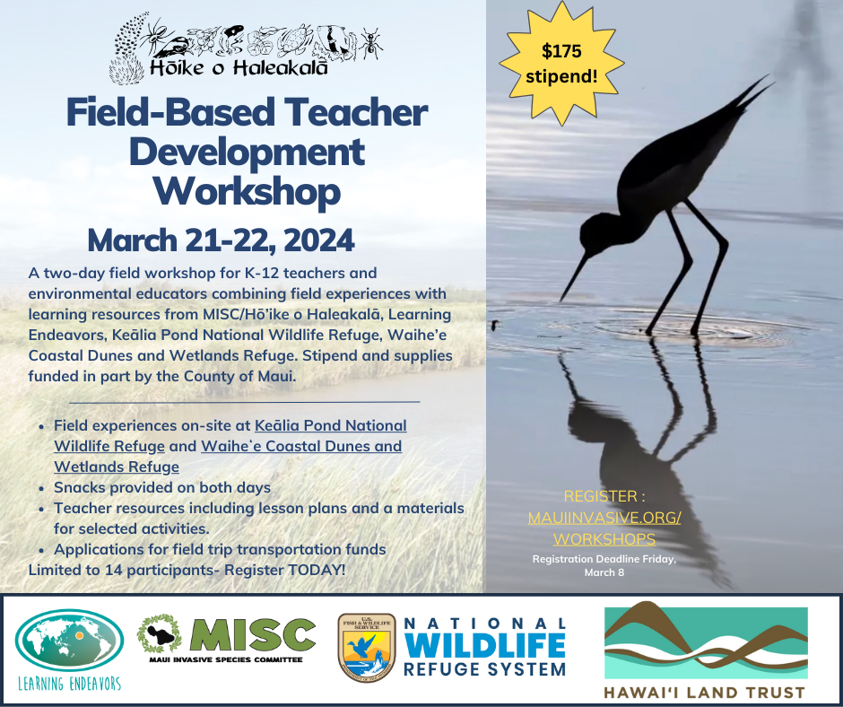](https://mauiinvasive.org/workshops/)

|  |
| --- |
| **Course for Educators on Maui** |

<https://mauiinvasive.org/workshops/>

|  |
| --- |
| Funding provided for this teacher workshop is provided in part from the County of Maui through Pili Koko and the Save the Wetlands Hui.  The Learning Endeavors Wetland Warriors Initiative continues to grow through multiple partnerships and events.  Learn more at:  [*https://www.learningendeavors.org/wetlands*](https://learningendeavors.us18.list-manage.com/track/click?u=1bfaa77a5b704d185c980d736&id=1cca6a0eab&e=a6d85deec8) |

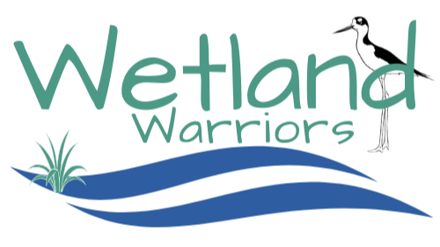

Do you want to help at the upcoming State Science fair? The need for all types of volunteers is great. Not only judges but volunteers to help with check in and much more.

April 1 – April 3, 2024 our link to volunteer form:

<https://www.hawaiiacademyofscience.org/volunteers>

[](https://www.hawaiiacademyofscience.org/volunteers)

[**ExploreLearning Gizmos**](https://gizmos.explorelearning.com/) **are award-winning virtual labs and interactive simulations that bring research-proven instructional strategies to life.** Click the image below to [learn more](https://drive.google.com/file/d/1212yadiqpcDjqhGZhzvMdN3zot4M8-Xq/view?usp=sharing)!

[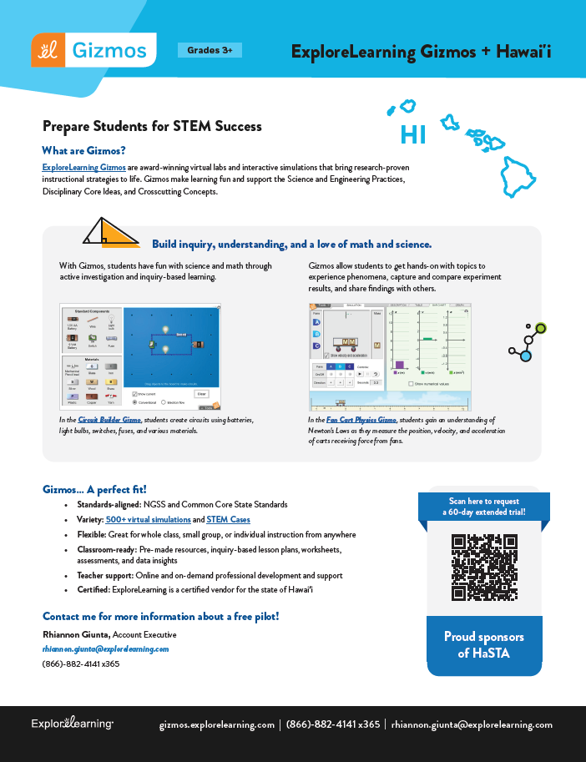](https://drive.google.com/file/d/1212yadiqpcDjqhGZhzvMdN3zot4M8-Xq/view?usp=sharing)