Join the fun TOMORROW! Sunday April 21, 2024

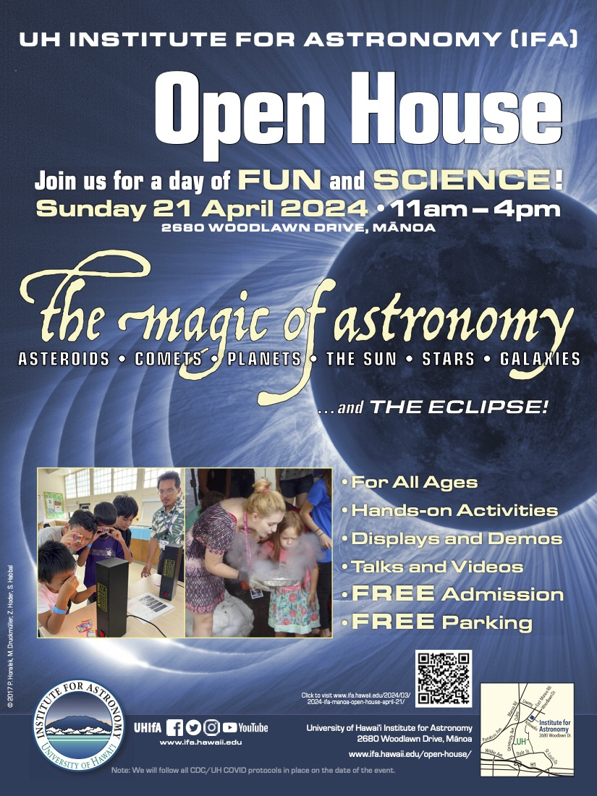



|  |
| --- |
| **Earth Day Resources For A Classroom**  **of Planet Protectors!** |

|  |
| --- |
| In preparation for Earth Day, NSTA has put together a collection of earth and environmental science resources for your classroom! Take a look by clicking the image below. |

[](https://www.nsta.org/earthday?utm_medium=email&_hsmi=302689111&utm_content=302691070&utm_source=hs_email)

[](https://sanctuaries.noaa.gov/education/ocean_guardian/)

The application is attached to this email as a separate document.

Join us for the 4th Annual

Hawai‘i Community Intertidal Exploration!

Sunday, May 5th

**Oneʻula Beach Park, ʻEwa Beach**

**8:00-10:00pm**

**Protocol at 8:00am**

**Exactly where is this event?**

* Drive to [One‘ula Beach Park](https://www.google.com/maps/place/One%E2%80%99ula+beach+park/@21.3054785,-158.0295514,132m/data=!3m1!1e3!4m5!3m4!1s0x7c007bf0bac4d0f7:0x86e912490aaff8cf!8m2!3d21.3052108!4d-158.0300933" \t "_blank)
* Event will take place at the [intertidal bench Diamond Head of the parking lot](https://goo.gl/maps/jbeC71h9pbCq5h8MA) (the first parking lot on the left)

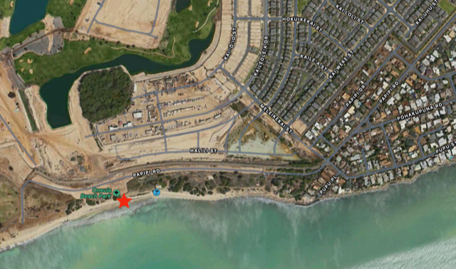

**How to participate in the biodiversity survey***(optional)***:**

* Use [iNaturalist](https://www.inaturalist.org/" \t "_blank)—download the app and make your own account. [Click here for directions](https://docs.google.com/presentation/d/1pC9EPBP1BP6IR8a8yb0ajDx2WQGKNFPfEx1dASX9oic/edit?usp=sharing) on how to use iNaturalist.
* Take pictures of the organisms you see—limu (algae), invertebrates, and fish!
* Link your pictures to the iNaturalist project "[Intertidal of Hawai‘i](https://www.inaturalist.org/projects/intertidal-of-hawai-i).”

Go to our [website](https://www.oceaniaeducators.org/blank) for more details about the day!   
  
**Questions?** Contact Joanna Philippoff ([philippo@hawaii.edu](mailto:philippo@hawaii.edu)) or Anuschka Faucci ([anuschka@hawaii.edu](mailto:anuschka@hawaii.edu))  
  
Looking forward to see many of you, Joanna & Anuschka

