Aloha and Happy April 5, 2024

## Lots of science going on this month from Oninzuka Day of Exploration at University of Hawai’i West Oahu tomorrow April 6 – the eclipse on Monday, April 8 (IfA resources below) and many upcoming Earth Events.

## 

## Livestream: Hawaiʻi eclipse – Monday April 8, 2024

IfA will launch a free livestream showcasing the partial eclipse unfolding over the islands on April 8, followed by total eclipse observations from the continental U.S. [Tune in online for live images, commentary and Q&A at 6:30 a.m. Hawaiʻi time.](http://YouTube.com/UHIfA)****

[NASA’s Eclipse Site](https://science.nasa.gov/eclipses)

## 

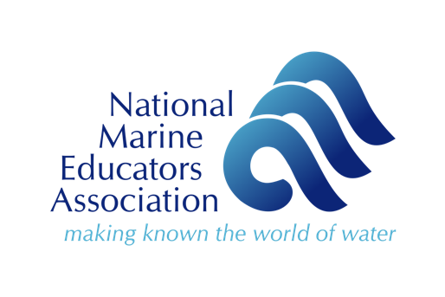

Aloha HaSTA!

Please consider running for the Oceania Board! Oceania is the local chapter of the [National Marine Educators Association](http://www.marine-ed.org) (NMEA).

**Oceania is looking to recruit 4–8 new board members.**

**Interested? Please fill out this**[**board nomination form**](https://docs.google.com/forms/d/e/1FAIpQLSfDDEe2qHxd1ywKlogtC6sUFVu6FQTh3lmnEK7z8F3QCGQ-Ng/viewform?usp=sharing)**by April 19**.    
  
Goals for the new board include:

* Quarterly board meetings
* Planning events and activities for members

**From the new board we'll determine executive positions (e.g., vice chair, secretary).**

We are looking for board members who represent the diversity of marine education, including but not limited to:

* Formal educators (e.g., K–12 teachers)
* Informal educators (e.g., aquarium staff)
* College/university educators and researchers
* ʻĀina-Based educators
* Scientists who engage in outreach
* Science communicators
* Government agency educators

We are also looking for the board to be representative of the geographic area of our chapter including representation from multiple Hawaiian Islands, American Samoa, Guam, the Commonwealth of the Northern Mariana Islands, Australia, and US-affiliated and other islands in Oceania.

**Self-nominations (**[**board nomination form**](https://docs.google.com/forms/d/e/1FAIpQLSfDDEe2qHxd1ywKlogtC6sUFVu6FQTh3lmnEK7z8F3QCGQ-Ng/viewform?usp=sharing)**) are due April 19.**  
Voting will take place the following week via an election ballot to Oceania's listserv. Election results will be shared in early May.

**If you have questions please email Oceania chapter representative Cris Wagner (**[**oceanmindedmama@gmail.com**](mailto:oceanmindedmama@gmail.com)**).** *Please share widely to people you think might be interested!*

|  |  |
| --- | --- |
|  |  |

|  |
| --- |
| Hello,    My name is Aalia Angirish and I am working with Heather Arnett who is a STEM coordinator in Aerospace Engineering at the University of Illinois at Urbana-Champaign. Over the past couple of years, she has worked on a DoD grant to help develop rocketry courses and teacher professional development focused on exploring the relationship between mathematical skills and physics performance through modeling, hands-on applications, and quantitative and qualitative data analysis with the aim of sparking interest in STEM and, more specifically, space. The Introductory to Rocketry course has two pathways, Novice (<https://learnrockets.spacelab.web.illinois.edu/course-toc?course=9>) and Advanced (<https://learnrockets.spacelab.web.illinois.edu/course-toc?course=6>) to provide scaffolding for learners from middle to high school. We have supported 1000+ students and held two summer professional developments. Through intentional iterations from implementation learnings, our aim now is to expand the reach of the materials. We are excited to be offering free professional development for both the Novice and Advanced courses this summer at the University of Illinois Urbana Champaign and Southern Illinois University Carbondale, and we would love to offer this opportunity to your teachers. Our professional development opportunities provide foundational knowledge and active learning, including rocket build and launch, along with the development of a classroom implementation plan. Participants are provided with a $500 stipend to attend one of our week-long summer rocketry professional developments and leave with all the materials and supplies to perform course activities, including the rocket build (~$1350). I am attaching our flyers with details and codes for registration. Registration closes Sunday, May 5, 2024. Thank you for your time and consideration.  Thank you,  Aalia Angirish  B.Sc Aerospace Engineering @ UIUC |

[aaliaa2@illinois.edu](mailto:aaliaa2@illinois.edu)

