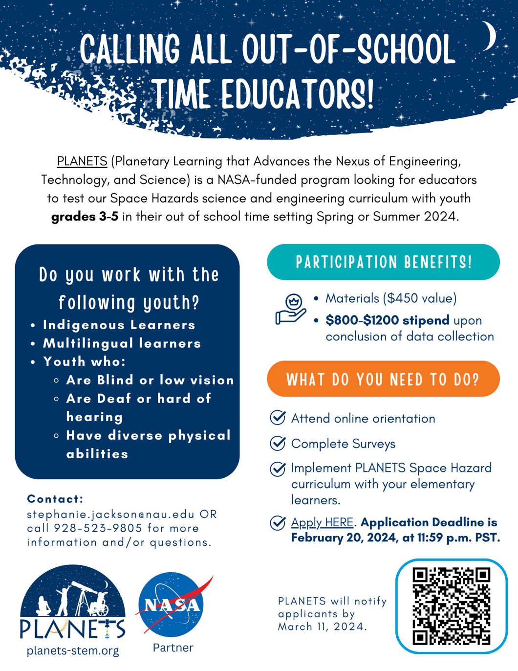
APPLY NOW!

iTeach808 is back in person this year. See below for registration form and details. Free teacher PD conference
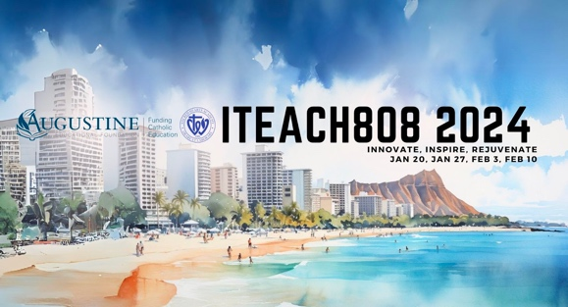 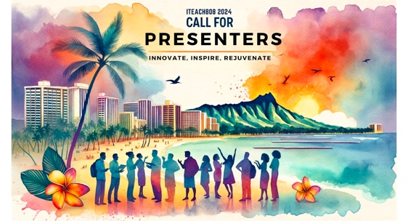
We are thrilled to invite you to the iTeach808: AI Workshops for Hawaii School Educators, hosted at Sacred Hearts Academy, Honolulu. This year's conference, generously sponsored and offered at no cost to you, focuses on the impactful integration of AI in education and the crucial aspect of teacher well-being.
Announcement Video here:
https://www.youtube.com/watch?v=L7FUGD8SLKQ
In Person Format from iTeach808 2024:
Complimentary Professional Development: Courtesy of our sponsors, Augustine Educational Foundation and Sacred Hearts Academy, this enriching experience is presented free of charge. This is our way of giving back to the dedicated educators in our community.
Empowering Educators with AI and Well-Being Focus: Dive into the world of AI, learning how it can enhance your teaching methods and personal growth. Equally important is our emphasis on mental health and resilience, crucial in today's educational landscape.
One Half-Day, Immersive Cohort Experience: Choose one half-day session from four available dates (January 20, 27, and February 3, 10) to join a cohort of fellow educators. Each session is structured to offer deep, collaborative learning in a supportive environment.
Why Should You Attend?
Tailored to Hawaii School Educators: Specifically designed for the unique needs and culture of Catholic schools in Hawaii.
Interactive Cohort Format: Engage in three focused workshop sections - AI in Education, Cohort Presentations, and Hands-on AI Activities.
A Platform to Share and Grow: Present your insights and experiences. Submission is open and presenting guarantees your spot in a cohort.
Registration Is Simple and Crucial!
Slots are limited and filling up fast. Register here to secure your participation in this one-of-a-kind professional development opportunity.
https://www.iteach808.com/registration
Call for Presenters - Share Your Journey:
We encourage you to submit a proposal for a 10-15 minute live presentation or a 5-minute pre-recorded video on themes of AI applications, mental health, and more. Submit your proposal here.
https://www.iteach808.com/submit-proposal
Join us for iTeach808 2024 and be a part of a movement that values innovation, support, and community in education.
Warm regards,
The iTeach808 Team
www.iteach808.com
Aloha,
Happy New Year!
Just a friendly reminder that applications for the MEd Curriculum Studies STEMS² track Cohort 10, which will start in the Summer 2024 term, will close on 02/15/24. As of today the cohort is half full. If you are interested in applying or know anyone who is interested, we would encourage you to submit your application as soon as possible as admission happens on a rolling basis.

We have decided to host one more online information session (sign-up here):
General Information Session (ONLINE) - Get an overview of the program, including explanations of the STEMS² track's values and structure, along with information on how to apply.

January 30 5:00 - 6:00 pm HST
All sessions will be held in our STEMS² Zoom Room. To attend please sign-up here

For more information about the program please visit: https://coe.hawaii.edu/stems2/

Feel free to share this email with others who may be interested. Thank you again for your support of the STEMS² track! If you have any other questions please contact us at stems2@hawaii.edu.

Thank you!
Tara O'Neill and Jaime Lum
STEMS²
^{stems2@hawaii.edu}

Hello from Canada!
My name is Heather and I’m the Communications Manager at the Krembil Research Institute, part of University Health Network, in Toronto – which is Canada’s largest research and teaching hospital.
I wanted to let you know about an amazing free, virtual event coming up for students interested in a career in science or medicine. On Friday, February 9th, from 10-11am ET, we’ll be hosting our 4th annual virtual event for students, in support and recognition of International Day of Women and Girls in Science.
This is a free public education event geared to middle school, high school and undergraduate students of all backgrounds & affiliations. The event will feature short, engaging talks from three highly accomplished female scientists and doctors. Drs. Tina Felfeli (Donald K. Johnson Eye Institute), Nikita Looby (Schroeder Arthritis Institute) and Nardin Samuel (Krembil Brain Institute) will each give student-friendly presentations on their current work in vision, arthritis and brain research & clinical care, to inspire the next generation of scientists (all genders). See attached brochure for more info on each of our featured speakers.
Our moderator is Dr. Chika Stacy Oriuwa, one of Time magazine’s “2021 Next Generational Leaders” and an accomplished physician, spoken word poet, and advocate for racialized and marginalized populations.
This is a unique opportunity to hear from trailblazing scientists & clinicians about their backgrounds and career paths, their day-to-day lives in the lab, and what inspires and motivates them to work toward making discoveries that could one day help to save lives.
Click here to register (registrants will also receive a recorded link) and please consider sharing this info and registration link with your members, colleagues, or anyone who may be interested. *ALSO* please note that upon registration, teachers have the opportunity to submit questions on behalf of their students or their classrooms, for the scientists to answer during the live Q&A.
If there are any opportunities to include this info & the registration link in any upcoming eblasts, social media posts or newsletters, we would be most appreciative. And please consider sharing these posts on Twitter, Facebook, Instagram & LinkedIn. Here is a ‘sneak peek’ sizzle video of what to expect, too. J
Last year, we had over 4,000 students & teachers join us from as far away as Zimbabwe, India & Australia and this year we are aiming even higher!
Any questions? Please let me know, and thank you in advance for your support.
Heather Sherman (she/her)
Manager, Communications
University Health Network
Neuroscience | Arthritis | Vision
A Healthier World: Find out how UHN is delivering on our vision here.
T: 416-603-5294 Email: Heather.sherman@uhn.ca

